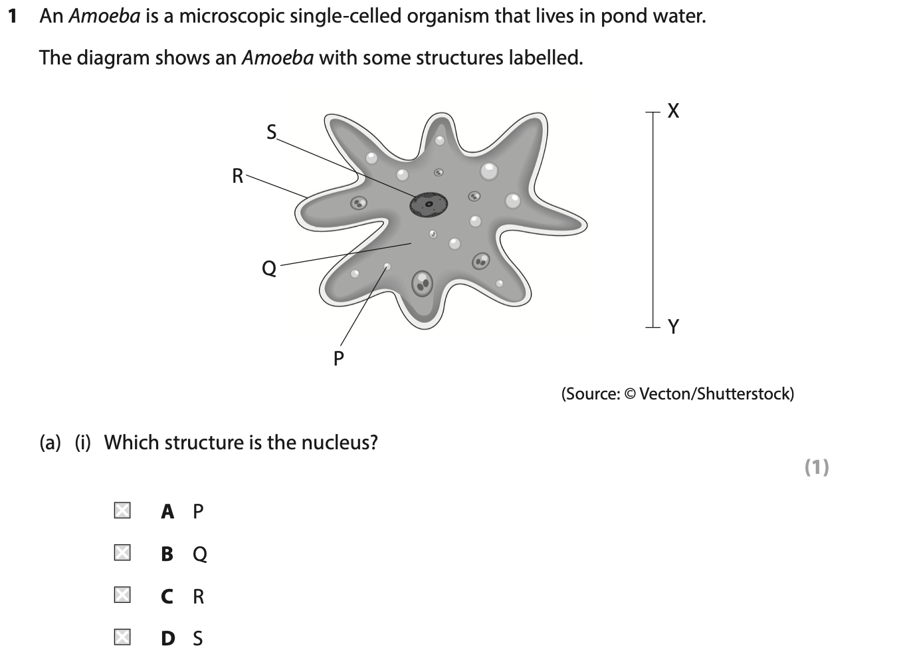
Answer: ________
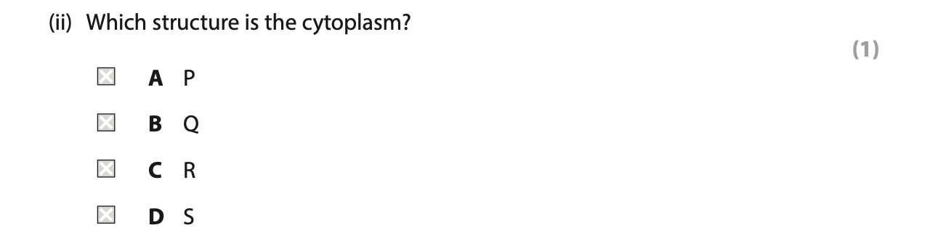
Answer: ________
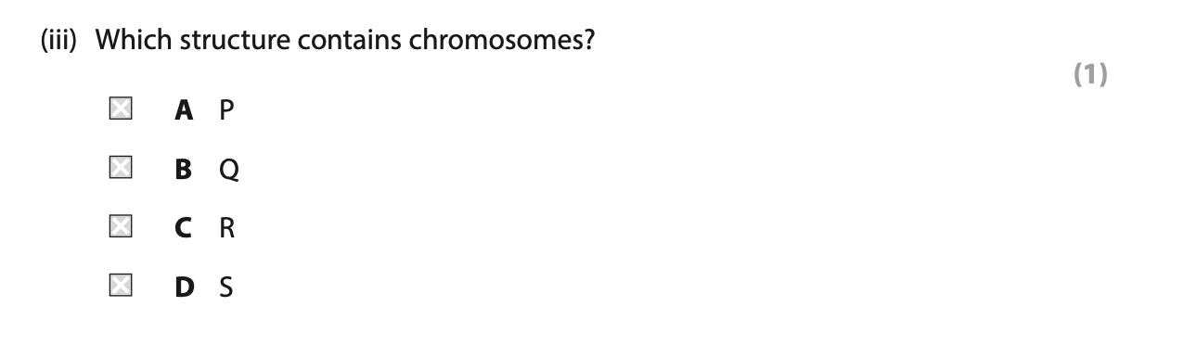
Answer: ________
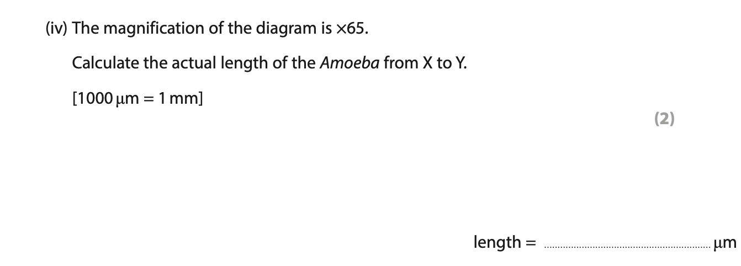
Answer: ________

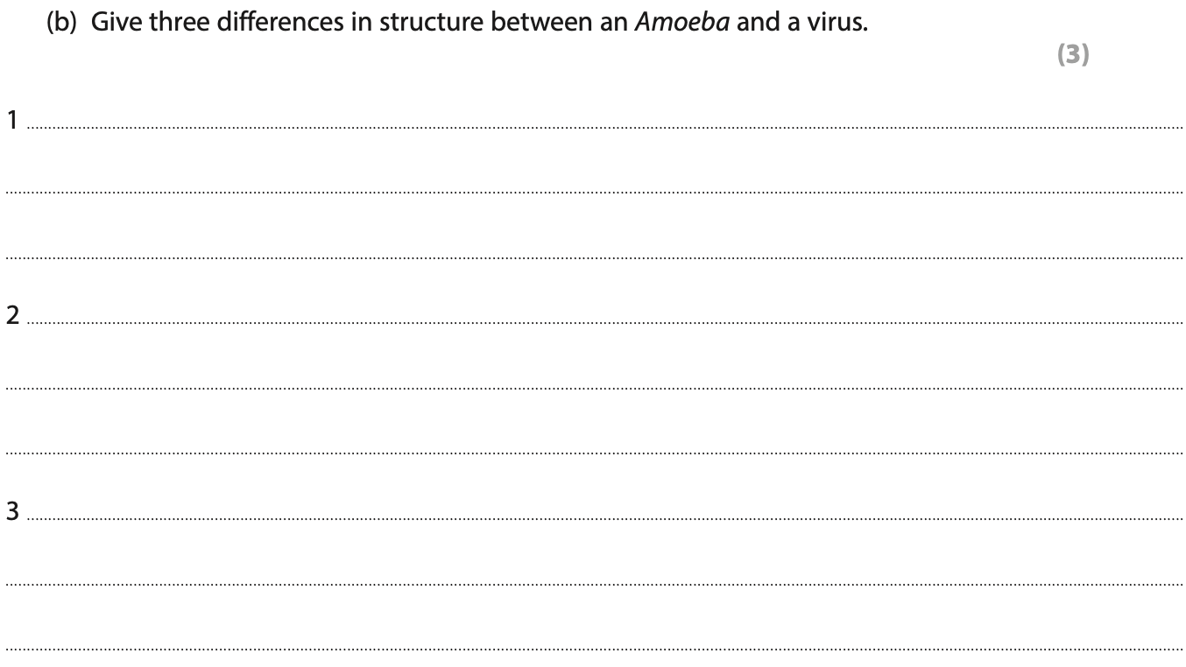
Answer:
________________________________________________________________________
________________________________________________________________________
________________________________________________________________________
________________________________________________________________________
________________________________________________________________________
________________________________________________________________________
________________________________________________________________________
________________________________________________________________________
________________________________________________________________________
________________________________________________________________________

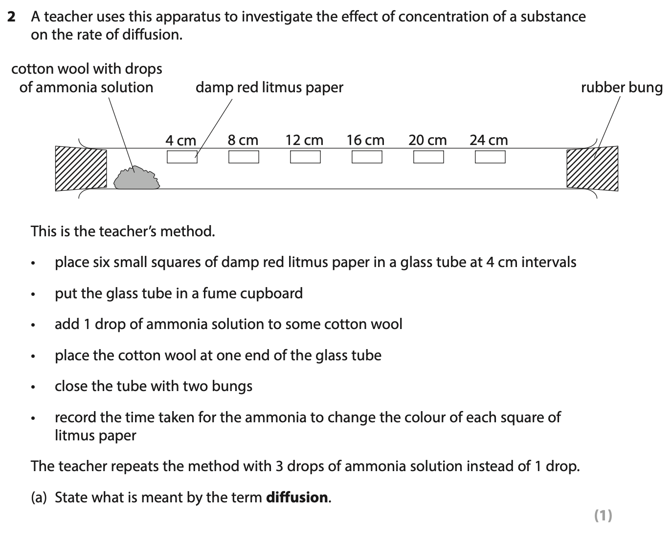
Answer:
________________________________________________________________________
________________________________________________________________________
________________________________________________________________________
________________________________________________________________________
________________________________________________________________________
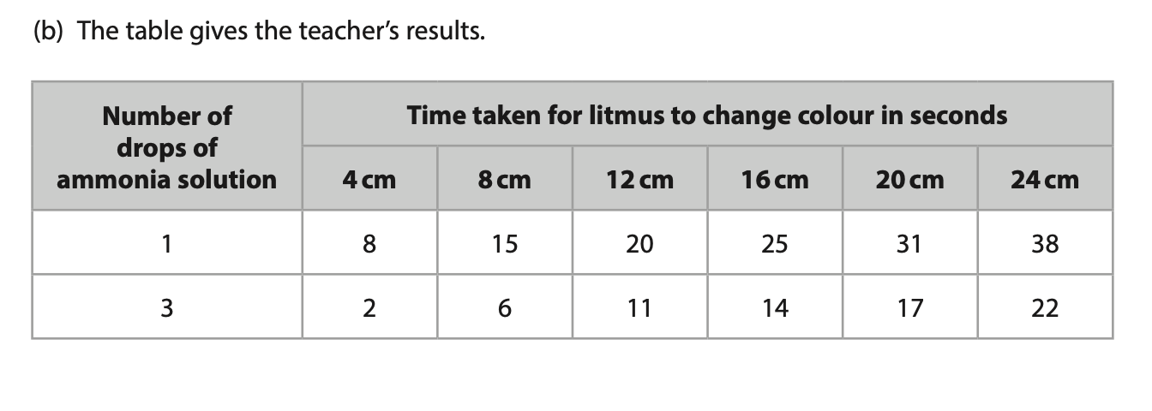
Answer:
________________________________________________________________________

Answer:
________________________________________________________________________
________________________________________________________________________
________________________________________________________________________
________________________________________________________________________
________________________________________________________________________

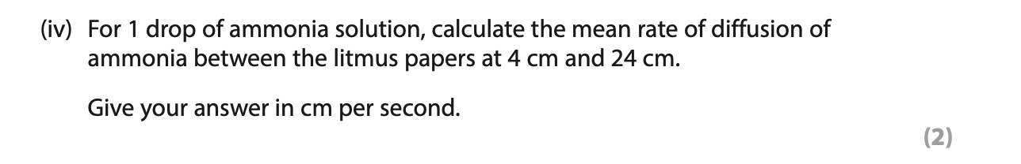
Answer:
________________________________________________________________________
________________________________________________________________________
________________________________________________________________________
________________________________________________________________________
________________________________________________________________________

Answer:
________________________________________________________________________
________________________________________________________________________
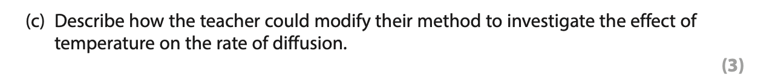
Answer:
________________________________________________________________________
________________________________________________________________________
________________________________________________________________________
________________________________________________________________________
________________________________________________________________________
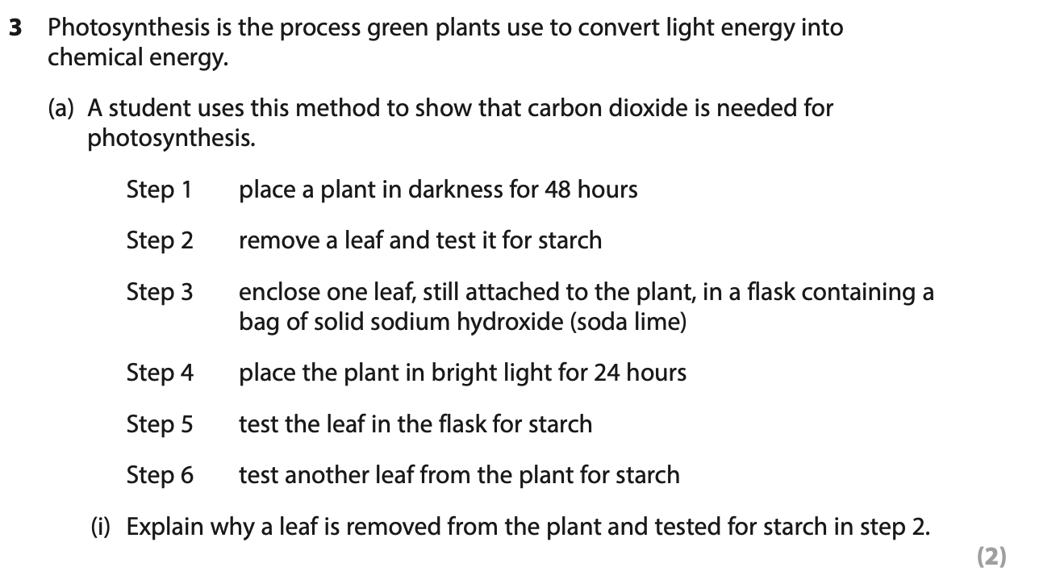
Answer:
________________________________________________________________________
________________________________________________________________________
________________________________________________________________________
________________________________________________________________________
________________________________________________________________________
Answer:
________________________________________________________________________
________________________________________________________________________
________________________________________________________________________
________________________________________________________________________
________________________________________________________________________
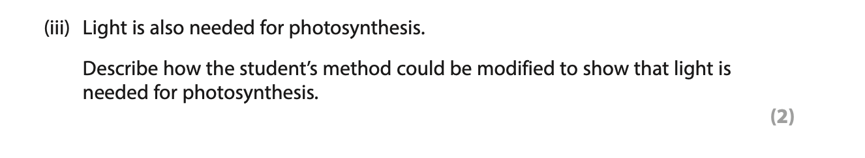
Answer:
________________________________________________________________________
________________________________________________________________________
________________________________________________________________________
________________________________________________________________________
________________________________________________________________________
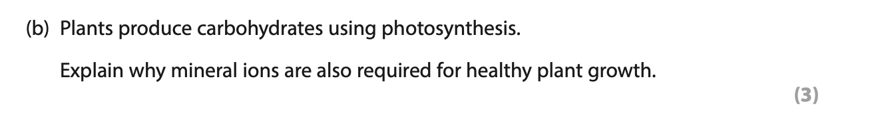
Answer:
________________________________________________________________________
________________________________________________________________________
________________________________________________________________________
________________________________________________________________________
________________________________________________________________________
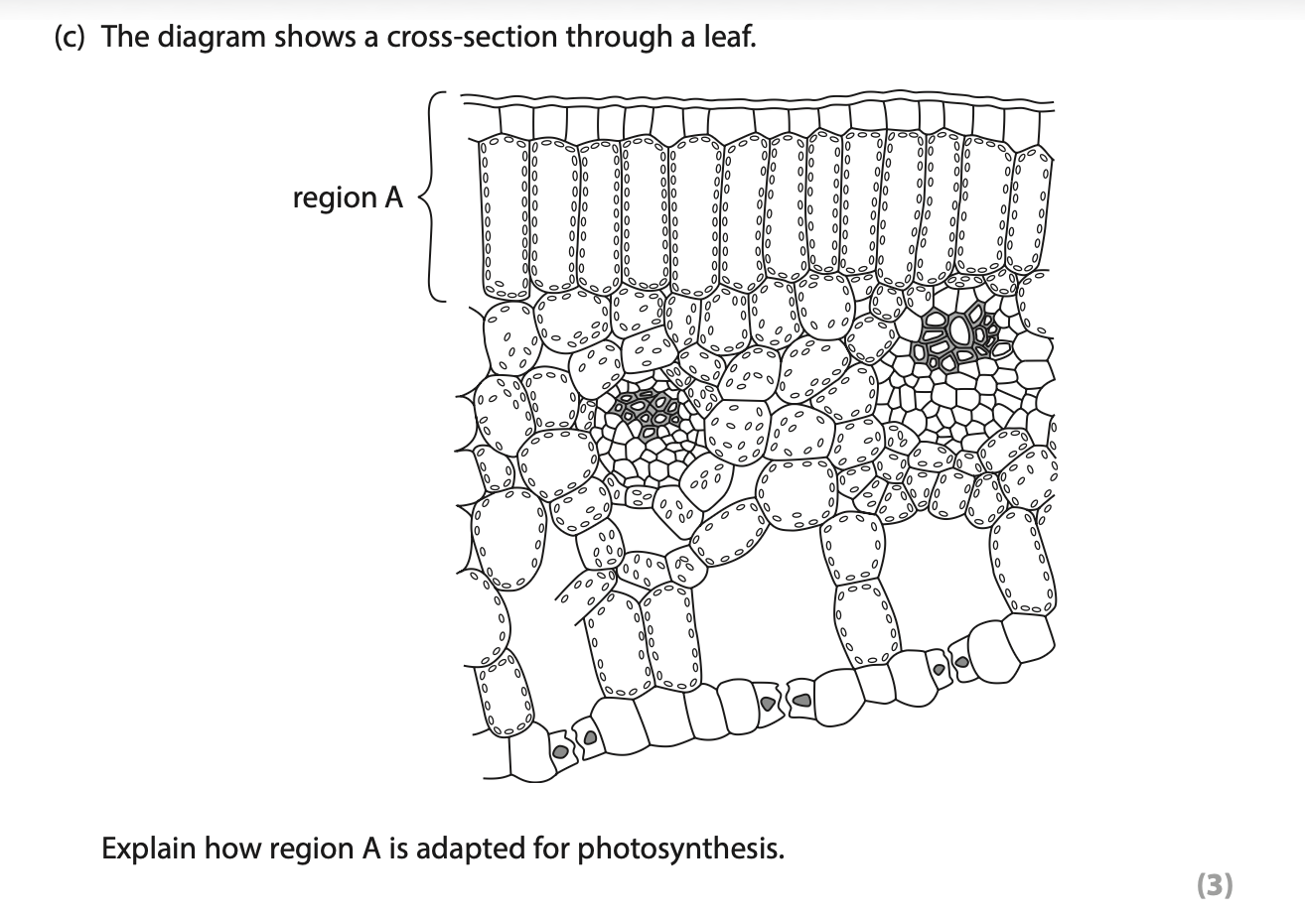
Answer:
________________________________________________________________________
________________________________________________________________________
________________________________________________________________________
________________________________________________________________________
________________________________________________________________________
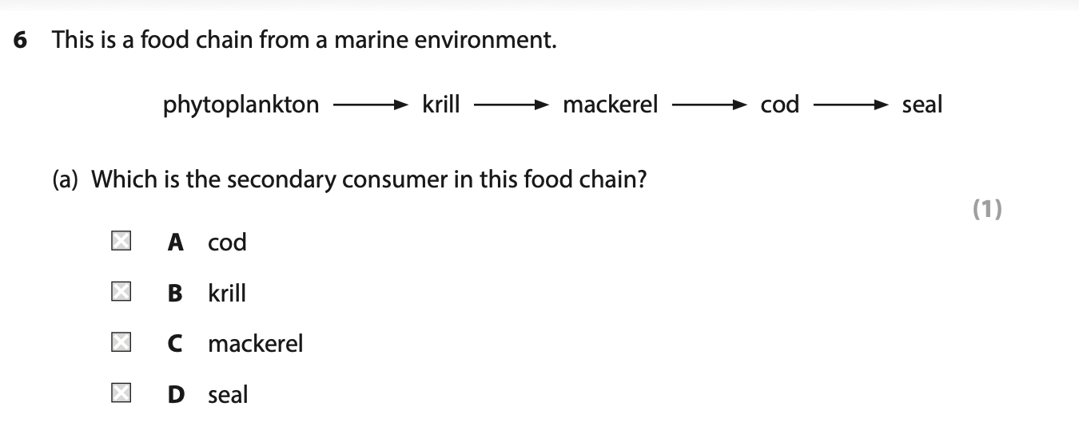
Answer: _______

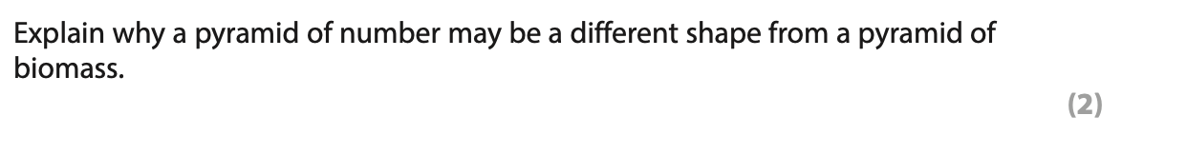
Answer:
________________________________________________________________________
________________________________________________________________________
________________________________________________________________________
________________________________________________________________________
________________________________________________________________________

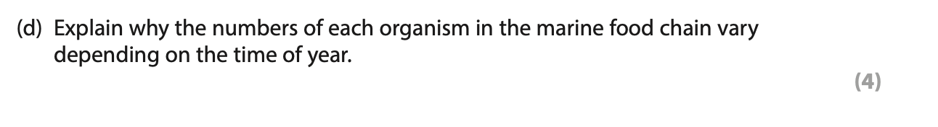
Answer:
________________________________________________________________________
________________________________________________________________________
________________________________________________________________________
________________________________________________________________________
________________________________________________________________________

Answer:
________________________________________________________________________
________________________________________________________________________
________________________________________________________________________
________________________________________________________________________
________________________________________________________________________

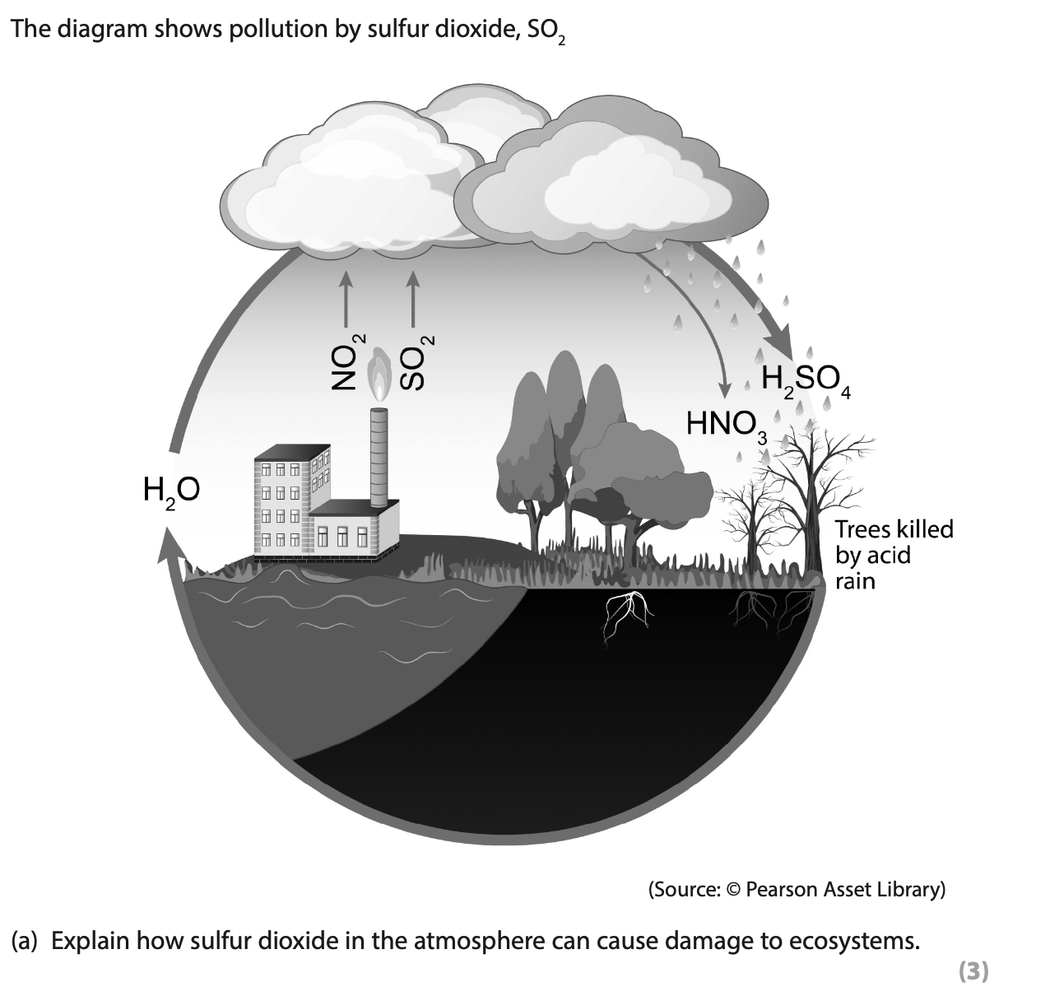
Answer:
________________________________________________________________________
________________________________________________________________________
________________________________________________________________________
________________________________________________________________________
________________________________________________________________________
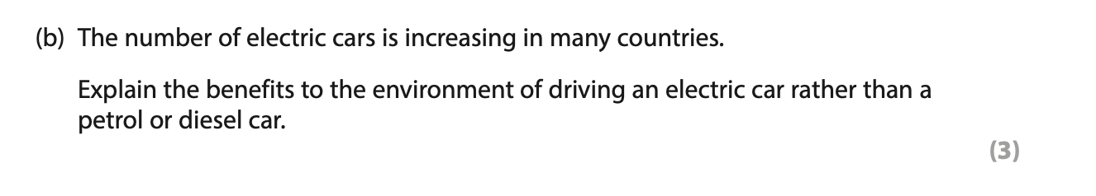
Answer:
________________________________________________________________________
________________________________________________________________________
________________________________________________________________________
________________________________________________________________________
________________________________________________________________________
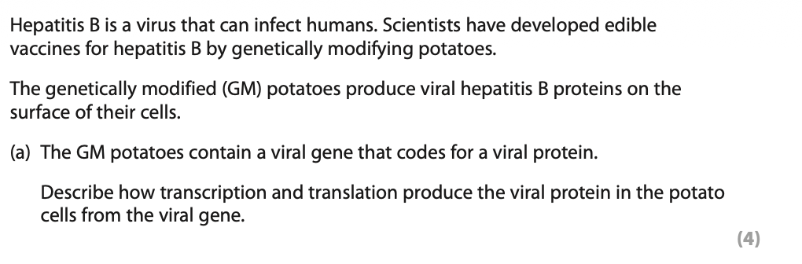
Answer:
________________________________________________________________________
________________________________________________________________________
________________________________________________________________________
________________________________________________________________________
________________________________________________________________________
________________________________________________________________________
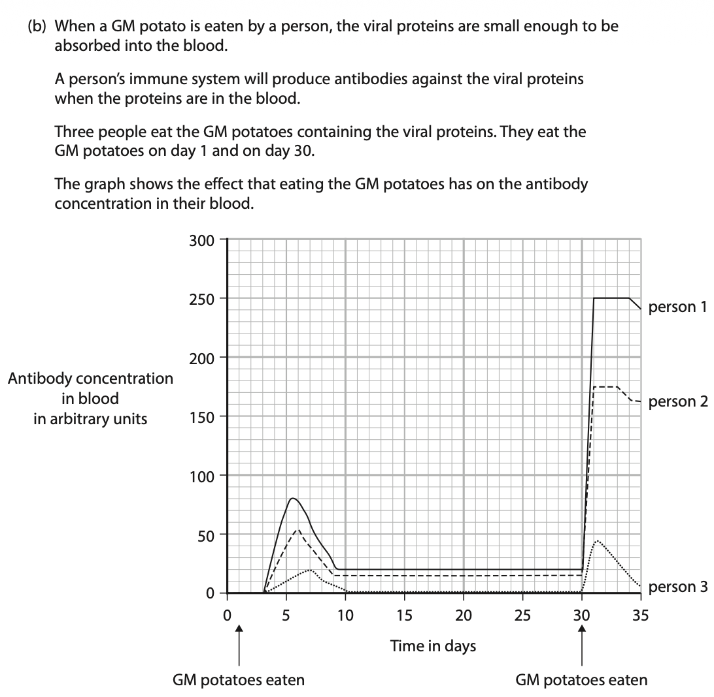
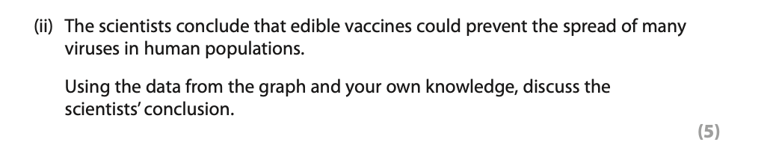
Answer:
________________________________________________________________________
________________________________________________________________________
________________________________________________________________________
________________________________________________________________________
________________________________________________________________________
________________________________________________________________________
________________________________________________________________________
________________________________________________________________________
________________________________________________________________________

